Data Visual & Preprocessing

Parameter | Details
Date | 08 March 2026
Team ID
Project Name | VoltEdge: EV Analytics Portal
Maximum Marks | 2 Marks

Data Visual & Preprocessing
1. Data Connectivity & Preparation
- Database Integration: The dataset was stored in a PostgreSQL database. A connection was established in Tableau using the PostgreSQL connector, ensuring a structured relational data flow.
- Preprocessing Steps:
  - Data Cleaning: Used SQL queries in pgAdmin to verify row counts and column integrity. In Tableau, null values in the Price and Range columns were filtered out.
  - Field Renaming: Technical headers were renamed (e.g., top_speed_kmh to Top Speed (km/h)) for dashboard clarity.
  - Data Typing: Assigned "Geographic Roles" to State/Region fields to enable the EV Charging Stations Map of India.
- Calculated Fields:
  - Count: COUNT([Car]) — to determine the number of models per brand.
  - Count_powertrain: COUNT([PowerTrain]) — to analyze the distribution of drive types (AWD, RWD, FWD).

2. Business Questions with Visualizations
- Q1: What is the regional distribution of charging types? 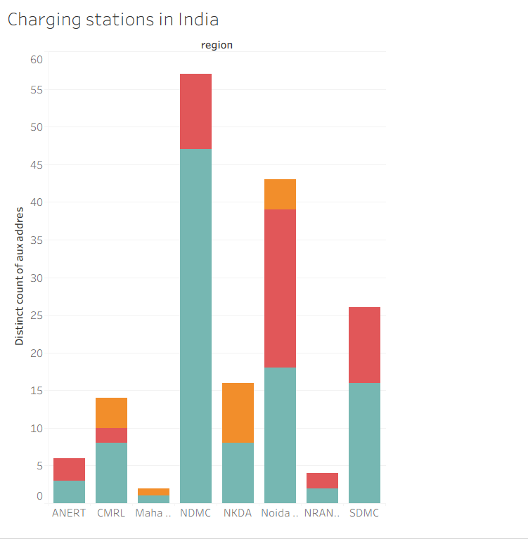

- Q2: Where are the infrastructure clusters?
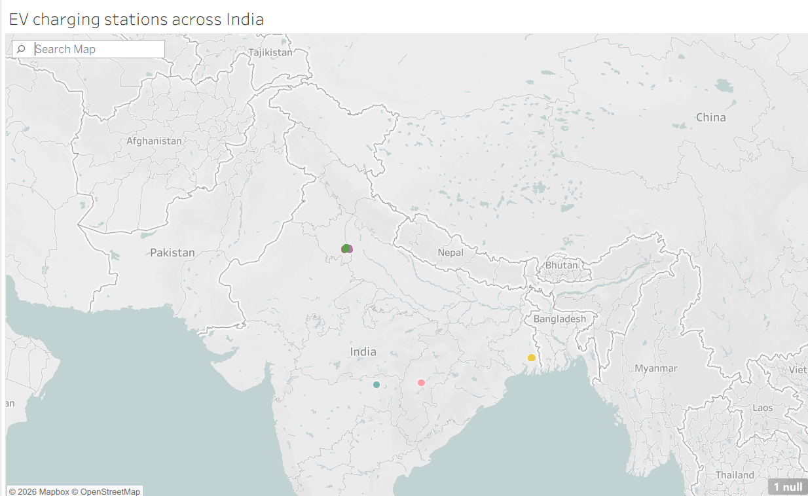

- Q3: Which brands lead in top-tier performance?
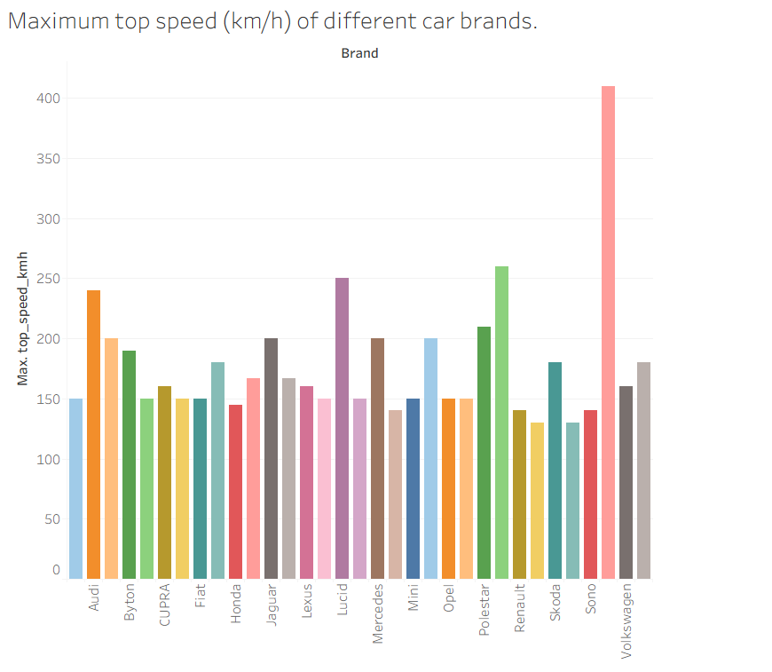

- Q4: How does the market split by vehicle category?
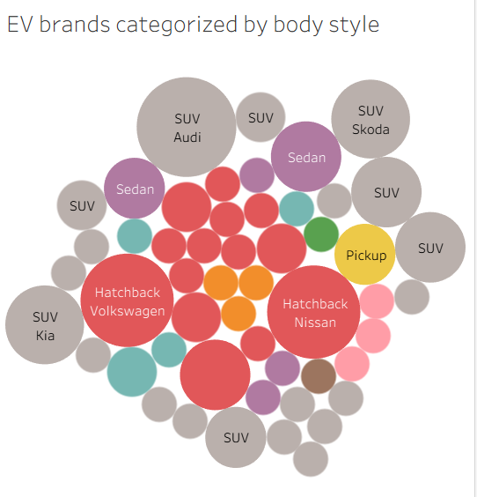
- Q5: Which brands are the most energy-efficient for fleet use?
